CREATE DATABASE ecom;

USE ecom;

SET SQL_SAFE_UPDATES = 0;

CREATE TABLE category (

category_id INT AUTO_INCREMENT PRIMARY KEY,

category_name VARCHAR(255) NOT NULL,

avg_price_in_category INT NOT NULL,

no_of_products INT NOT NULL

);

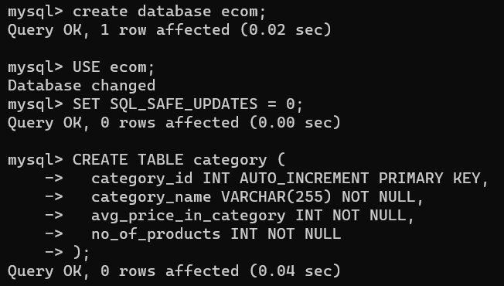

#1 insert Query

INSERT INTO category

(category_name,avg_price_in_category,no_of_products)

VALUES

("Smart Phones",10000,1000),

("Mens Clothing",1000,20000),

("Toys",200,50000),

("Electronics",3000,90000),

("Food",200,1000),

("Medicines",200,2000000),

("Pet Food",500,100000);

SELECT * FROM category;

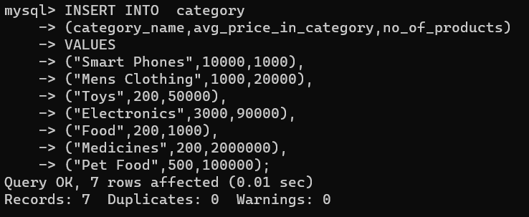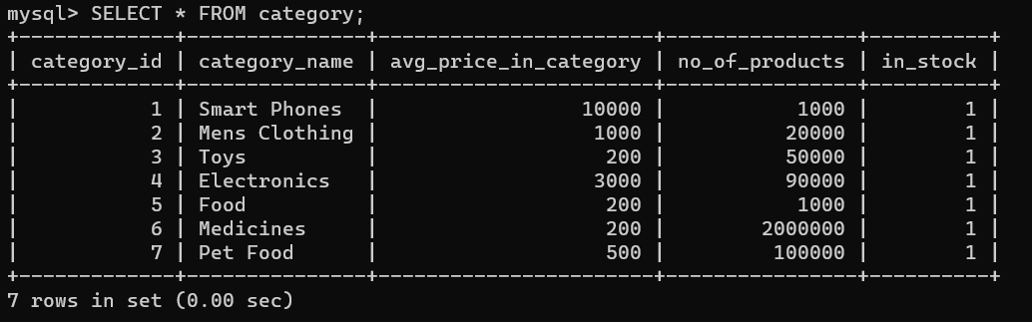

# 2. SELECT QUERY

SELECT category_name

FROM category

WHERE no_of_products>1000 && avg_price_in_category<5000;

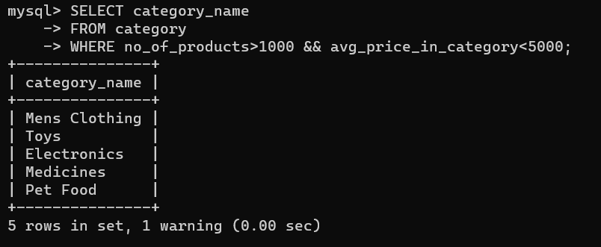

# 3. UPDATE QUERY

UPDATE category

SET category_name="Children's Toys"

WHERE category_name="Toys";

SELECT * FROM category;

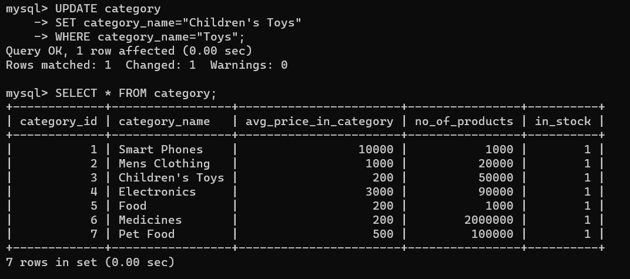

# 4. Delete Query

DELETE FROM category WHERE avg_price_in_category<1000;

SELECT * FROM category;

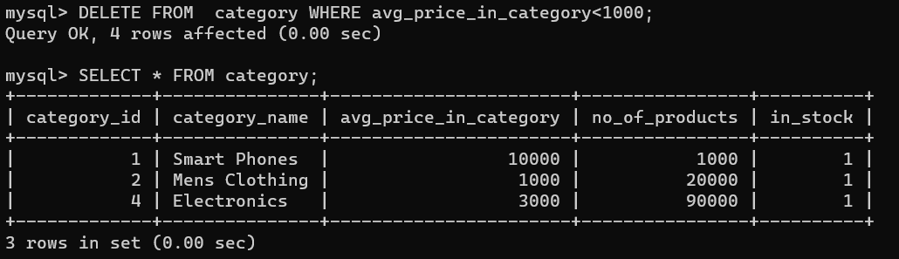

# 5. Drop column

ALTER TABLE category

DROP COLUMN in_stock;

SELECT * FROM category;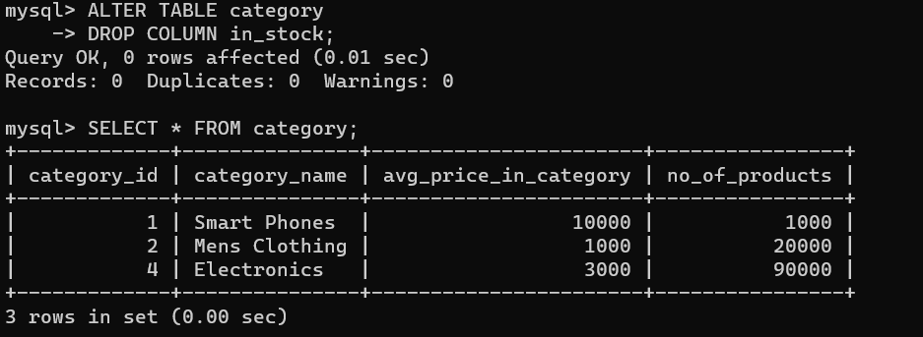

# 6. Add Column with default value

ALTER TABLE category

ADD in_stock TINYINT DEFAULT (1);

SELECT * FROM category;

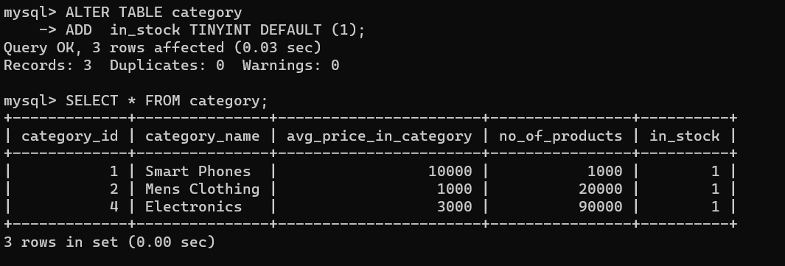

# 7 LIKE QUERYS with % operator

SELECT * FROM category

WHERE category_name LIKE "Smart%";

SELECT * FROM category;

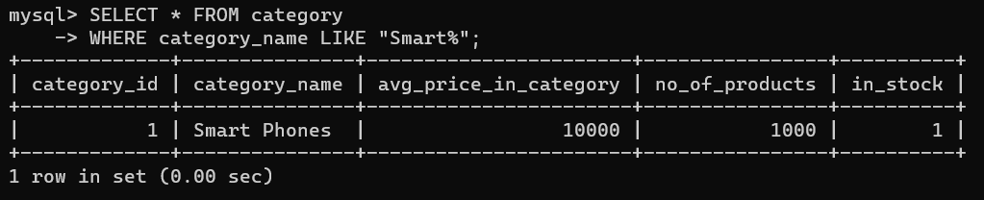

# 8 LIKE QUERY with _ operator

SELECT * FROM category

WHERE category_name LIKE "_lectronics";

SELECT * FROM category;

# 9 LIKE QUERY With _ and % operator

SELECT * FROM category

WHERE category_name LIKE "_lectron%";

SELECT * FROM category;

